Chapter 12, Solution 74.

Consider the circuit shown below.
Z = 60  j30 
Z
Z
2080 V
+
−
I₁
I₂
208-60 V
−
+

For mesh 1,
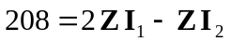

For mesh 2,
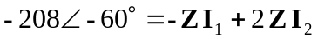

In matrix form,
 